**Golf Shot Rating user guide.**

This user guide is in three parts. The first part is using the app to play a round of golf and get Strokes Gained statistics at the end of the round. The second part is participating in leagues. The third part is tagging greens.

1. **Play a round of golf.**

At the first screen the user is presented with four options.

* Login
* Register
* Continue as guest
* Tutorial

If the user chooses to continue as a guest then they have all the functionality of the app except for the ability to export their rounds or join in leagues.

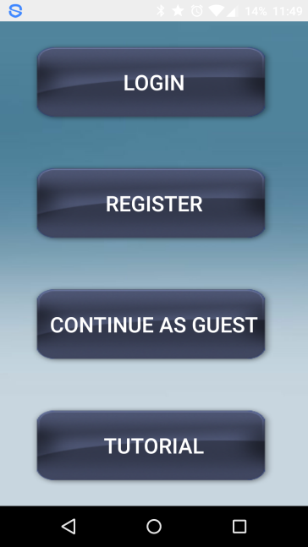

If the user chooses to Register then they will be taken to this screen:

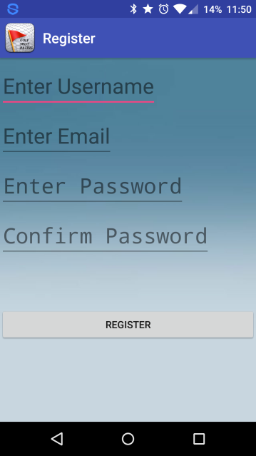

Here they can register their username and password. Upon doing this they will be taken to the Login screen where they can enter their username and password.

Once this is done they will be taken to this screen:

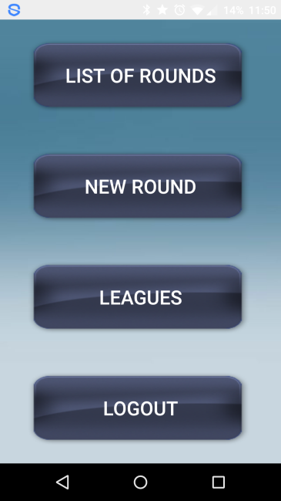

If they now choose to play a round of golf they will click the ‘New Round’ button.

This will bring up the following screen:

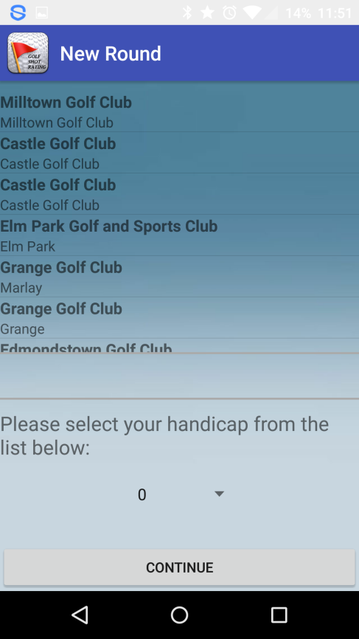

This screen gives the user a list of courses near their location. They then choose which course they are playing and enter their handicap. They finally click on ‘Continue’ and they are brought to the main shot input screen. Initially this screen will have ‘greyed’ out buttons and the GPS icon will be red. When a good GPS signal is received the icon will turn green and the buttons will be enabled.

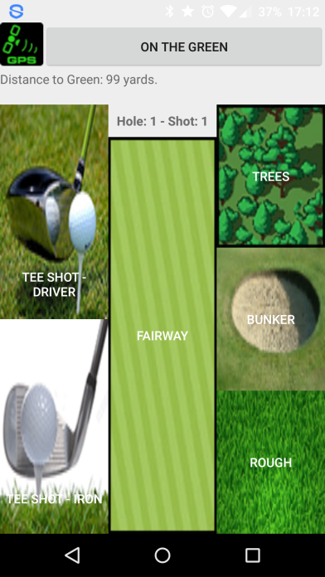

The user then clicks on a button representing their ‘lie’ for every shot they hit. E.g. If they are hitting a driver off the tee then they click, ‘tee shot – driver’, if they are in the rough, they click the button labelled, ‘rough’ and so on until they are on the green. At this point they click the, ‘On The Green’ button and this takes them to a screen with an image of a golf green:

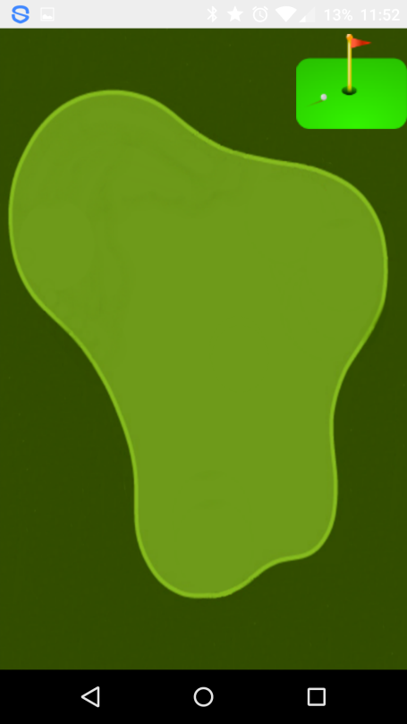

To record a shot here the user simply swipes their thumb or finger across the screen from left to right or right to left. The device will vibrate to indicate that a shot has been recorded. When the ball is in the hole the user stands by the flag and clicks on the, ‘Flag’ image in the top right corner of the screen. This ends the hole and brings up a summary of how the golfer did on that hole:

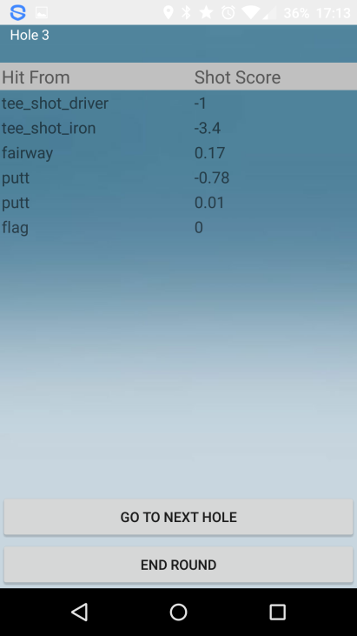

If the user rotates the device to landscape mode they will be presented with a side scrollview of all of the holes and they can see scores for each shot on each hole they have played. Here is an example of this screen after a user has played 3 holes:

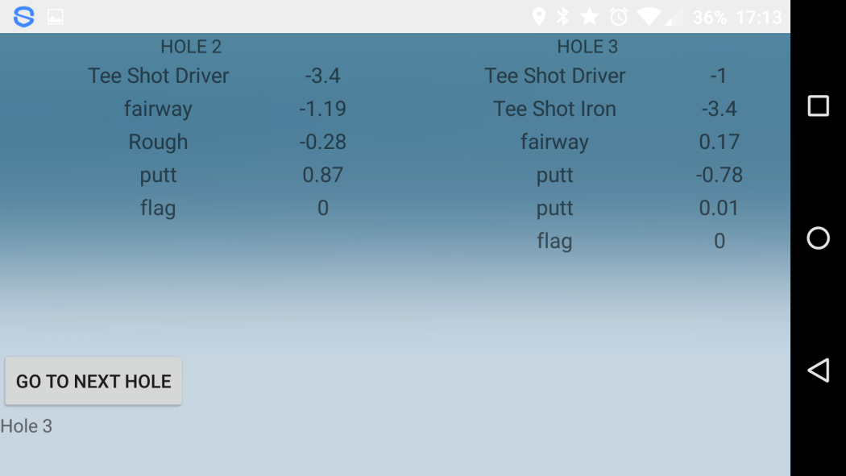

When all 18 hole have been played (or the user clicks, ‘End Round’ on the hole summary page) they will be presented with a Strokes Gained summary of how they did for this round.

1. **Leagues.**

Only when a user has registered can they join leagues. The leagues in Golf Shot Rating are designed to enable golfers to play in leagues against friends or strangers in different areas of the game. The leagues are split up in four areas.

* Driving.
* Long game (250 – 100yds from the pin).
* Short game (100yds form the pin and in).
* Putting.

On the main screen (if a user has logged in) they will see a button called, ‘leagues’. If they click this button they will be presented with a list of leagues that they have joined. The list shows the names of the leagues, the type of league (e.g. driving league), how many days the league will still run for and the league code:

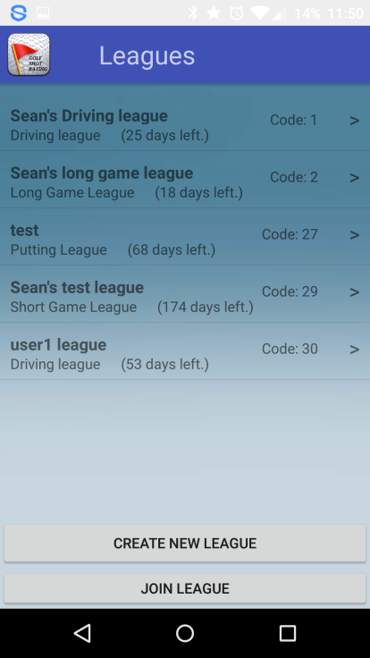

If a user clicks on any of these leagues they will be taken to that leagues page where the user can see all the members of that league and where they rank:

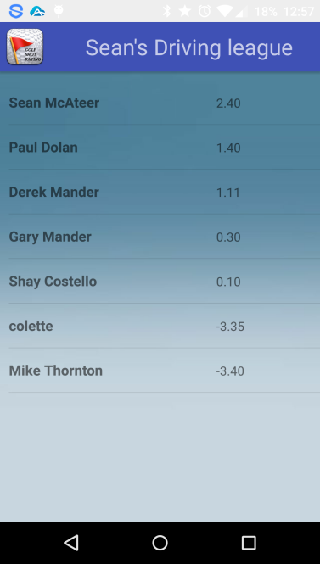

If the user is not a member of any leagues they can create a league of their own. If they click on the, ‘Create league’ button on the ‘leagues’ page they will be taken to this screen:

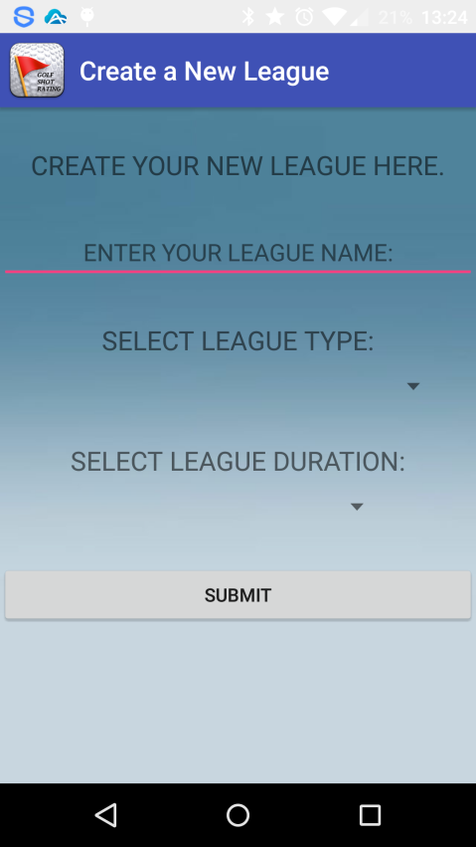

Here the user gives the league a name, selects the type of league e.g. Driving league, selects a duration that the league will run for and then clicks on ‘submit’. The league will be created and they can invite other users to join their league. To get others to join a league the user needs the league code. The league code is beside the league name in the list of leagues. The user simply sends the league code to whomever they wish and that user can then join the league.

To join a league, click on the, ‘Join league’ button on the list of leagues page. The user is then presented with a screen in which they enter the league code. Once this is done they are now a member of that league.

1. **Tagging Greens.**

When a user is using this app during a round of golf, the distance to the centre of each green will be displayed on the ‘Shot Input Screen’. This is only done on courses that have been ‘tagged’. If a course has not been ‘tagged’ then no distances are shown. If the user selects a course that has not been ‘tagged’ they will be given the option to ‘tag’ that course:

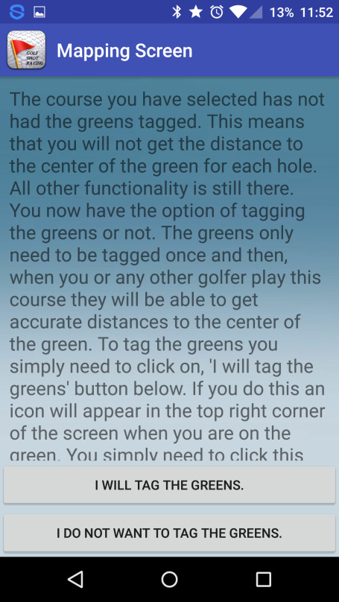

If the user chooses not to ‘tag’ the greens on the course they are playing it will not affect anything other than no distances to greens will be shown. If they choose to ‘tag’ the greens then the process is very simple. Whenever a user who is ‘tagging’ a course has clicked the, ‘On the Green’ button on the Shot Input Screen instead of the normal image of a green there will now be ‘bullseye’ on the image:

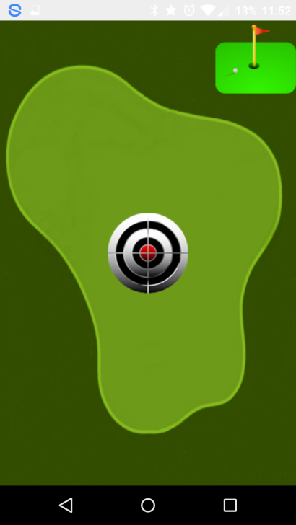

The user simply clicks on the bullseye when they are in the centre of the green and that green is tagged. They must do this before they click on the ‘Flag’ icon or they will get a warning telling them to ‘tag’ the green before finishing the hole. Once they have ‘tagged’ all the greens anyone who plays that course will have distance to the greens displayed on the Shot Input Screen.